**Instructor Signature: ________________________**

**Date: 1/24/2021**

Introduction

The Raspberry Pi is a $35.00 computer that was developed by Cambridge University Computer Science Researchers to increase the interest and enrollments into hardware and computer science engineering careers. Currently, there are 6 different types of Raspberry Pi models and each has their applications and advantages. The majority of resources including OS, project ideas, and tutorials can be found at the Raspberry Pi Foundation website or <http://raspberrypifoundation.org>. There are lots of projects that can be developed with this platform; entertainment centers, desktop, home automation, wearables, IoT applications, security, and so much more…

|  |  |
| --- | --- |
| Image result for picture of raspberry pi 3 | https://upload.wikimedia.org/wikipedia/commons/thumb/e/e4/RaspberryPi_3B.svg/300px-RaspberryPi_3B.svg.png |

There are many options of Pi’s and Pi kits that could be use in getting an introduction to a 32 bit system. The Sparkfun Starter Kit 3 has a selection of basic input/output components, power supply, HDMI cable, etc., that allow for exploration of many topics. Researching these topics you will find plenty of tutorials and DYI projects for various operating systems, different programming options, and the ability to control hardware. Enjoy the exploration and remember to play!

**Outcomes:**

**As a result of this activity you will be able to –**

1. Demonstrate installing Raspbian operating system on the Pi 3.
2. Place Raspberry Pi into the plastic case
3. Identify the parts within the Raspberry Pi Kit
4. Configure Basic Settings on the Raspberry Pi system.
5. Install XDRP software for running headless operation.
6. Update and Upgrade the Operating System.
7. Properly shutdown the Raspberry Pi

**Equipment and Supplies:**

1. Raspberry Pi Kit (See Kit Inventory in Getting Started Module)
2. Monitor with either HDMI connector or use HDMI to DVI adapter with monitor
3. HDMI Cable
4. Keyboard with USB Connector
5. Mouse with USB Connector
6. CAT5 cable for connecting to a network/Internet

Note: If you have a “smart TV” you can use the HDMI connector without the cable adapter and select the HDMI input that the Pi is “connected to” for operating the system.

Tech tip: I have found that keeping a separate set of notes on the various commands and processes related to Linux, Network and Device identification, access procedures, and specific steps for programming the Pi is invaluable. Keeping notes can be done electronically but I actually have a 3 x 5 inch spiral notebook that I use for short-cuts and steps, and valuable information.

Procedure I: Inventory Kit and Getting Started with the Pi

1. Take a few moments to verify the contents of the kit. Below is the list of items:

* Raspberry Pi 3 x
* Sparkfun Pi Wedge (Preassembled) x
* Sparkfun FTDI Basic Breakout – 3.3V x
* Breadboard – Full Size (Bare) x
* Pi Tin (Case) for the Raspberry Pi (Black or Clear in Color) x
* 16.0GB microSD (Preloaded with OS) x
* microSD USB Reader x
* Red, Blue, Yellow, and Green Tactile Buttons x
* Red, Blue, Yellow, and Green LEDs x
* Resistor 330 Ω 1/8 Watt PTH – 20 Pack x
* Raspberry Pi GPIO Ribbon Cable – 40 pin, 6” x
* Sparkfun USB Mini-B Cable 6.0 ft x
* Wall Adapter Power Supply 5.1V DC 2.5A (USB Micro-B) x
* Jumper wires premium 6” M/F – 10 Pack x
* Jumper wires standard 7” M/M – 30 Pack x
* Pi Camera Module 2.0 Version (Not included in Pi 3 Starter Kit) added to RCC Textbook Bundle. x

1. Acquire the use of a Monitor, Keyboard, and Mouse to be able to connect the Raspberry Pi to install the OS. Also, have CAT5 cable and a router with internet connection ability to connect the Raspberry Pi to the Internet. If the monitor does not have a HDMI connector than a HDMI-to-DVI adapter for the cable is needed. Refer to the videos for connecting the hardware. There is equipment setup at both lab locations to assist with installing the OS and getting the Pi up and running. Once you run through the process of running headless with the Pi you will not need these components.
2. Properly align and push the micro SD Card (with pre-installed NOOBs software) into the connector slot. The microSD card will only plug into the slot in one orientation be careful not to force it into the slot. It only goes in one-way.
3. Plug the keyboard, mouse, and monitor into the Raspberry Pi before connecting the power supply to the unit. The CAT5 cable is only used if you want to get up on the Internet prior to configuring the Wi-Fi adapter embedded on the Pi3 or PiZero with Wi-Fi ability after the operating system is installed on the Pi. FYI… if using an older Pi model a Wi-Fi dongle.
4. After all of the cables are connected plug in the power supply and make sure the monitor is turned on. The Raspberry Pi will start to bring up the NOOBs software which will give you an option to install your choice(s) of operating systems. For this class we will install Raspbian which is the recommended full desktop operating system. Depending on what you want to do with your Raspberry Pi you might choose a different system. Again, it is typical to have multiple microSD cards with various operating systems if you decide to have different distributions to play with on the Pi. In this class we will start off with the Raspbian Distro; select that option and then click on Install OS. Refer to Figure 1.

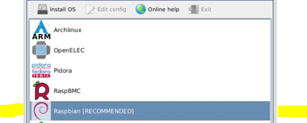Figure 1

Procedure II: Configuring Basic Settings on the Pi

1. After the installation is completed it is time to configure the Pi to work in the US. The steps you will complete are:
   1. Change the Location to US
   2. Change the Timezone to Pacific Standard Time (Los Angeles)
      1. Pacific is an option but I believe Hawaii does not use Daylight Savings and your clock will be an hour off.
   3. Set the Keyboard to US format for QWERTY
   4. Set the WiFi Country to US

Note; In the next section each change will be described.

1. Select the Raspberry Pi Icon on the main menu bar and scroll down to Raspberry Pi Configuration Preferences to change the Locale (Set Locale) from UK to USA. Refer to Figure 2

. 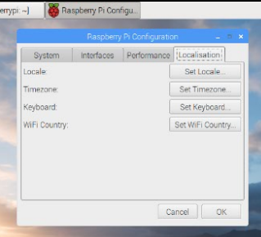 Figure 2

1. From the same section (Localisation) select the next option (Set Timezone) and change to Pacific Standard Time or Los Angeles.
2. Change the keyboard setting from the UK to USA by selecting the Set Keyboard preferences. Refer to Figure 2.
3. Change the WiFi Country by clicking on the Set WiFi Country option and change it to United States. After changing all of the Localization settings click “OK” to accept the changes. It will ask you to reboot the system and go ahead and click OK to complete the setting changes.
4. Once the Pi has rebooted if you want to change the sensitivity on the mouse (it should be okay in the default setting); follow the steps below.
   1. Changing the mouse sensitivity is a personal preference and you will find that option by selecting Preferences from the Main Pi icon and then choosing Keyboard and Mouse to change the0 settings. Refer to Figure 3.

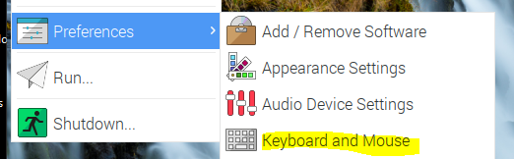

Figure 3

1. Click on the Main Menu Pi Icon and select the Raspberry Pi Configuration menu. Click on the tab for Interfaces. Enabling the interfacing settings will also need to be adjusted to gain access to the Pi resources. To get started enable the Camera, SSH, and VNC settings. You can turn on all of the resources or leave the other items disabled until we use them later in the course. Refer to Figure 4.

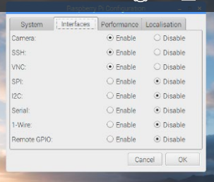 Figure 4

Tech Tip: The SSH or secure shell protocol allows you to log into the Pi via a cell phone for example. Be careful with this setting because in a public network this means others can access your Pi.

Note: A message that the settings will not update until the Raspberry Pi is rebooted will pop-up. Go ahead and select OK to let the Pi reboot.

Procedure III: Updating and Upgrading the Operating System

The Raspbian Linux Kernel is updated periodically and it is easy to get these new updates and upgrades using the terminal and terminal prompt. Refer to Figure 5. To use these commands we will need to become a Linux super user do (sudo) because we will be updating and upgrading the operating system and it requires administrative permissions to complete the process. We will spend time later learning more about sudo, file and folder permissions, and Linux basics.

The difference between updating and upgrading is that update will download the package lists from the repositories but does not actually install anything. The upgrade command performs the function and tries to intelligently handle changes with dependencies with newer versions of packages. It will attempt to prioritize the most important upgrades at the expense of the less important ones. It may remove some packages if necessary, however, this doesn’t happen often. The apt-get command executes getting the application from the repositories.

1. Verify that your Pi is connected to the Internet.
   1. Use the hard-wired CAT5 cable to connect to the Internet through the router/network.
   2. Click on the Wi-Fi icon  and see which networks are available to connect to that are visible. In Lab 2 we will edit to the two files to make sure the Pi will automatically connect to the Internet when powered up and a network is available. The Pi 3 model has a built in Wi-Fi adapter and may have already found the network.
2. Open up the terminal window  to use the command prompt. Refer to Figure 5

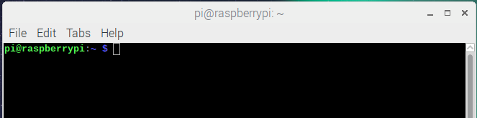

Figure 5

Installing software with Linux requires package managers and software repositories which is different than a Windows-based machine that you download and run executable files (*.exe) from a website. A package manager is similar to Google’s Play Store or mobile app store. The package manager is instructed by you (apt-get) to install a piece of software. The manager will automatically download the correct package from the configured software repositories, install the application, and set up the software. Unlike a Windows application that uses a Wizard to install software or worse you need to go find the executable file in the downloads folder. The package manager also deals with updates and again unless you configure the Windows application to check for updates it will not do this function automatically.

When using these two commands you will want to complete the update option first then upgrade. This procedure should be done periodically as you use the RPi unit to continue to upgrade the distro with the new applications that become available.

1. To update the operating system type the following command: *sudo apt-get update* and then *press enter*. You will notice a list of releases being updated on the screen and will look similar to the screen shot Figure 6. This could take some time to complete.

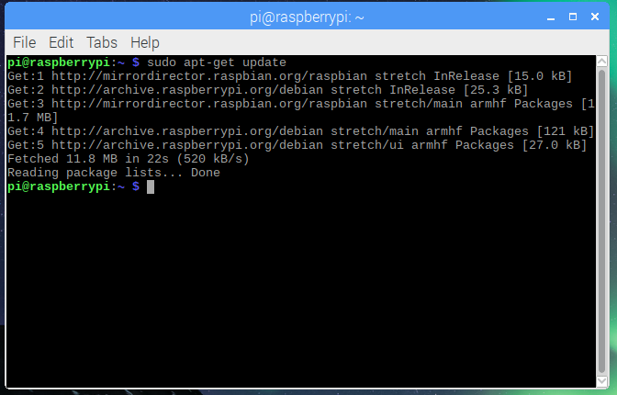Figure 6

1. To upgrade the operating system type in the following command: *sudo apt-get upgrade* and then *press enter*. Notice that it will be a prompt asking you if you want to continue. Type *Y* to continue and then *press enter*. Refer to Figure 7. This procedure must take some time so go get a soda… just depends on the speed of the microSD card.

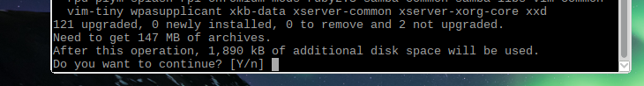

Figure 7

What does sudo stand for? Super User do

What does the command apt-get allow you to do?

Get an advanced packaging tool

Procedure IV: Installing XRDP software for Running Headless Procedure

Before we finish this lab let’s use the terminal window and install a piece of software called XRDP on the Pi so that you can access your Pi via the remote connection application on your PC. There are other applications than can be installed such as Tight Virtual Network Client or TVN that your book references but the XRDP software is real easy to use and does not require a lot of memory or additional settings. When the Pi first came out this software was part of the initial operating system. However, now you must go and get it using the *apt-get install*. If you have the Pixel OS installed on your Raspberry Pi here is a link to using the Virtual Network Connection (VNC) application if you cannot get XRDP.

<http://www.circuitbasics.com/access-raspberry-pi-desktop-remote-connection/>

1. In the next process we will be using the command prompt to install XRDP a light version of tight virtual network software to run headless.
2. Type the following command: *sudo apt-get install xrdp* and then *press enter*. Refer to Figure 8.

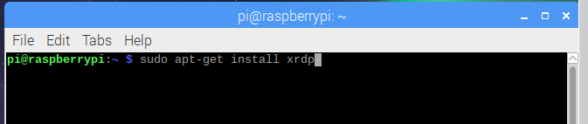 Figure 8

After the process starts to run a list of packages which will be read and built for the xrdp software. Once this application is installed we will be able in the next lab to configure the Pi to run in the headless mode.

How do you access the terminal on the Pi?

Click the terminal icon at the top of the screen.

Procedure V: Finding your MAC Address

When connecting to a network via the headless operation (see lab 2) you will want to know the MAC Address for your Pi. Determining the MAC Address can be done by:

* Type in the command “sudo ifconfig”
* Type in the command “ip address”

The ifconfig command is similar to the ipconfig on a PC where you are trying to determine the network information of your device. After you type in the command your results will look similar to Figure x. Where the information after “ether” represents the MAC Address. In this case my Pi 3 has a MAC Address of b8:27:eb:ec:88:99



If you type in the ip address command the results will look like:

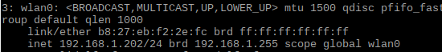

In the two examples on the previous page notice using ifconfig command that the MAC address is connected to eth0 (CAT5 cable network connection) and is b8:27:eb:ec:88:99

In the second example with the command ip address that the MAC address is connected to wlan0 (Wi-Fi connection) and the MAC address is b8:27:eb:f2:2e:fc

Two different Pi units with two unique MAC Addresses so it is important to know your address!

What is your Pi’s MAC Address: b8:27:eb:aa:27:ee

Do not worry about saving the current IP Address (dynamic) for the Pi it will change each time the Pi is connected to a network. It will be important to find the new IP address when logging into the Pi remotely in the next lab. In a later lab we will change the hostname and password to make it easier to find.

Procedure VI: Shutting Down the Pi

The Raspberry Pi does not have an on-off switch or reset button installed on it. There are two main ways of shutting down the Pi correctly which is important to do. If you just pull the power supply out of the wall socket you will run the risk of corrupting the micro SD card with the operating system on it.

1. On the task bar from the main menu on the desktop you can select shut down. The Raspberry Pi will not take long to power off and then you can disconnect all of the cables and store the Pi back in the kit box until your next session. (Disconnect the power cable last). Wait until the green acknowledge LED stops blinking before pulling the power supply cable and packaging up your Pi.
2. The other options for shut down is to type in the command prompt line in the terminal window:

pi@raspberrypi ~ $ sudo halt (this command only shuts off the processes and CPU but keeps the unit on).

pi@raspberrypi ~ $ sudo poweroff (includes powering down all processes, CPU, and the unit itself).

pi@raspberrypi ~ $ sudo shutdown –h now (similar to poweroff command).

Note: When working in remote desktop session I use the sudo poweroff command in the terminal session to power down. You will not be able to select the shutdown option from the GUI desktop menu.

1. Remove the microSD card and store it in the sleeve and plastic container for protection. It is not a good idea to leave the card inside the Pi in case the edge of the card gets jarred. If you decide to get more microSD cards to install different OS options on your Pi get some storage for them and label which one is which for future sessions.

Procedure VII: Placing the Pi in the Case

1. Wait for the acknowledge LED (green) to turn off before unplugging the Pi from the wall socket. It may take some time for the final processes of the OS to shut down before it turns off. Look for the blinking lights to stop (three to four blinks).
2. Disconnect all of the cables from the Pi.
3. Un-package the case for the Pi (two pieces) and align the Pi with the bottom shell before setting the top shell and closing the case together. It will snap into place. Again do not force the parts together the plastic is fragile and easy to break (spoken from experience). The case will snap into place when the alignment is correct. At this point you can pack up your kit and store it. The red box the kit comes in is a little bulky so finding a thinner plastic case that has clasps to keep it securely close it helpful.

Optional Procedure and will be explored in a later lab.

Procedure VIII: Re-Installing the distro Raspbian Jessie Operating System (OS) – when bad things happen?!

1. NOOBs (New Out of the Box) software allows for installing the OS without having to be connected to the Internet. The OS will be installed on the microSD card that comes with the kit. The NOOBs interface can be accessed by holding the “Shift key” down while the Pi is powering up to return to this application in case you want to install a different OS or you need to re-install Raspbian Jessie because it was corrupted. Refer to Figure 9
2. 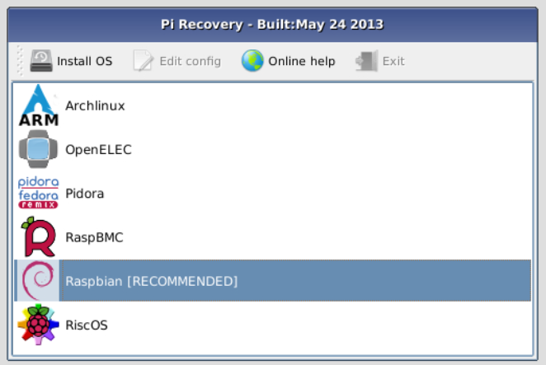Figure 9
3. 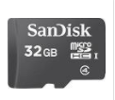An option is to purchase an additional microSD cards if you want to experiment with other operating systems and/or decide to back-up your current operating system is a plus; I have several depending on what I want to do. In a future lab we will look at the process of downloading NOOBs and Raspbian again from a new microSD card that needs to be formatted. Installing new operating systems and transferring files is why the Pi 3 Starter Kit includes a microSD Card-to-USB reader for these procedures.
   1. Check the speed ratings and capacity of various microSD cards before purchasing additional cards. A note about capacity is that the Pi3 can use 32GB and 64GB sizes but the card needs to be formatted to the FAT32 system and not the exFAT32 which most larger drives this size use. I have disks as small as 8GB that have OS distros for projects… again it just depends on what you want to do with the Pi.

Demonstrate:

1. Take a short video of your Raspberry Pi up and running and save it to a folder for Lab 1. If you are in lab at the time of the demonstration get an instructor signature and date of the demonstration.

Instructor Signature: _________________________________ Date: _______________

Research Questions for Lab Synopsis to be typed up and submitted electronically:

1. What does NOOBs stand for and what is its purpose?
2. Why is Raspbian Jessie a popular operating system for the Pi?
3. What is the difference between the commands upgrade and update? Which command should be done first?
4. What are the default configuration settings do all Pi Units come with when purchased? What do you need to change to make them work here in Oregon?
5. What questions do you still have at this point?
6. What tech-tips would you give someone at this time? (Nothing is not an answer for questions 5 and 6)

Alright now let’s start getting this Pi doing some things!